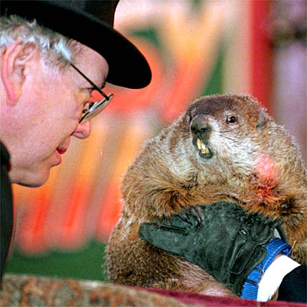


7:00 Open
Call to Order / Pledge of Allegiance
7:30 Citizen Comments
Approval of Minutes
Appointments
7:35 Housing Trust Committee Update

7:45 Economic Development Committee Update

Old Business
- Goals & Policies
- Debt Policy

New Business
- One Day License Request–Bartending Service of NE, 3/16/13

- Request for Best Buddies Bike Ride

- Request for Evan Henry Road Race

- License Agreement – 42 Main Street

- Park View Inn License Renewal

- FY 14 Budget Discussion

- Selectmen Warrant Articles

Upcoming Meetings
Announcements
Adjournment
Executive Session

